Basic LINKSYS setup

This is the basic linksys configuration page. Logon to the linksys box by connecting directly to the box with an Ethernet cable. Type 192.168.1.1 into a webpage, like the picture below. Click on the wireless button to see similar options. Remember your specific linksys box may show different options.

The most important part of your home wireless network is the SSID. The default SSID name is linksys. Change this to any word or alpha numeric combination such as:

smithnet, harpernet2, jimbobnet, Hollywood, micmouse, 123abc,
1jsu345lwo98

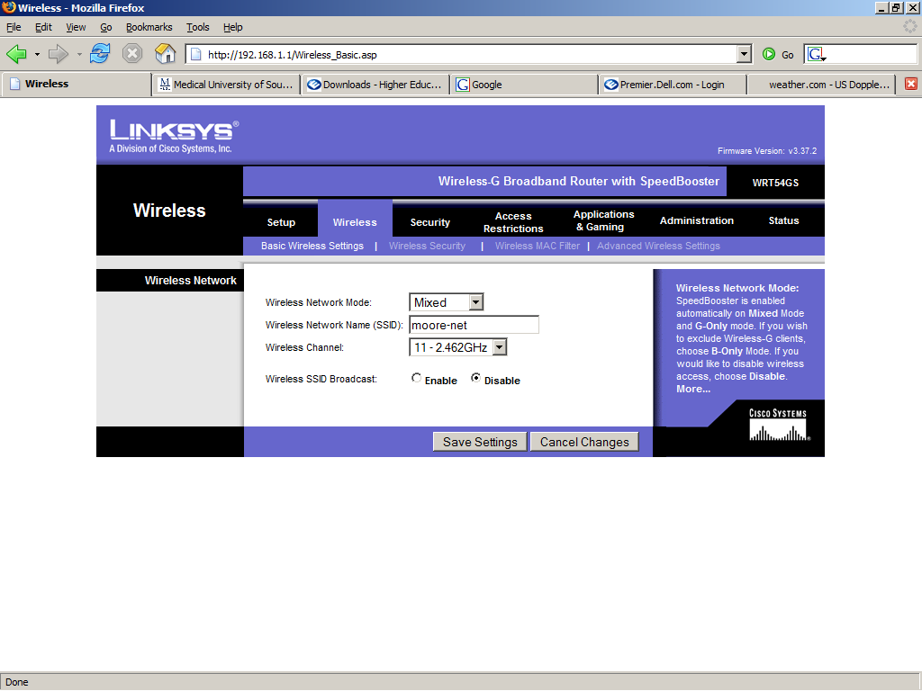

Then write down the name, or place a label on the linksys with the SSID. This is so you will not forget.
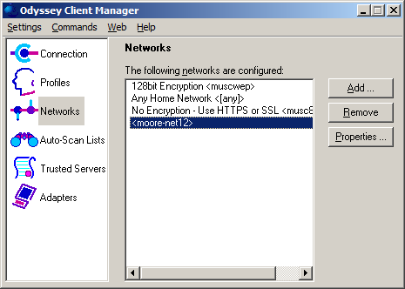
Next, choose to disable the broadcast of the SSID. This will keep your neighbors from using your wireless net for free. This also means you now have to ADD your wireless network SSID to the odyssey client.

If you have hidden your SSID or stopped the broadcast of the SSID name then you must now do the next step.
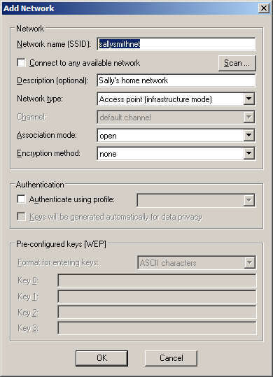
Open your odyssey client and click on networks.

CAUTION… do not change the other networks that are configured.

Click on add a network.

Type in your SSID for your home network.

Leave Network type, Association mode, and Encryption set the way they are here.

Now you should be able to unplug the Ethernet cable and switch to your wireless network at home.

You are done for basic setup.

You only need to continue if you have questions about 128bit encryption.
Home wireless setup using 128bit encryption

Plug up to you linksys with an Ethernet cable to do this configuration.
Make sure to have the power plugged up on your laptop.

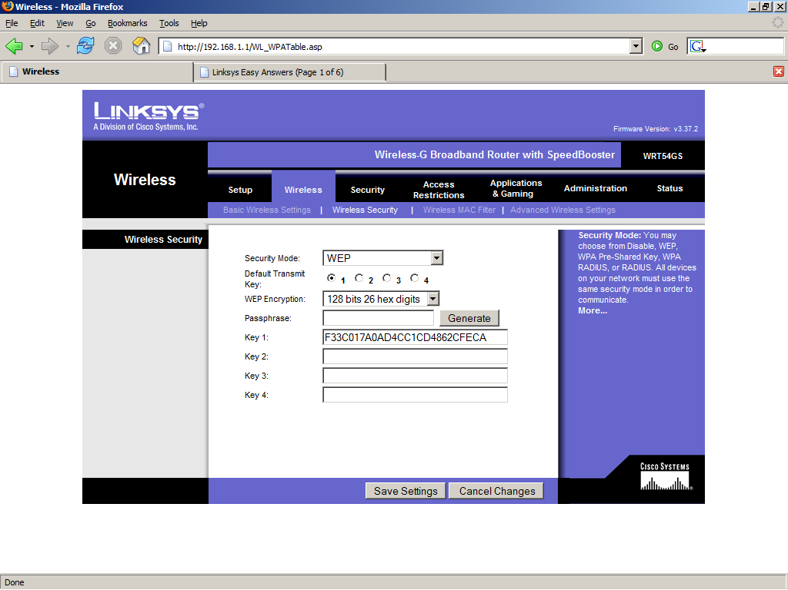

Under the wireless tab click on the wireless security tab.

Choose the options above: WEP, 128 bits 26 hex digits

Type in a word in the passphrase and click generate.
This will give you 4 keys. You only need one to make this work.
Clear the last three keys.

If your linksys does not have the generate button then make up a 26 digit alpha-numeric code to type in. Make sure to write down the code. Once you save this your wireless will not work until the next step is finished.
Open the odyssey client.
Click on networks, open the properties on your home network.

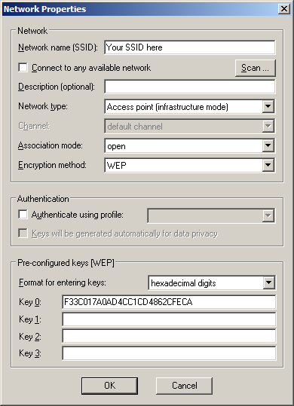

Set your encryption method to WEP.

Set “Format for entering keys” to hexadecimal digits.

Then type in you 26 digit alpha-numeric key

Double check for accuracy, one wrong character will cause this to not work.

Click okay and now your home wireless connection is encrypted using a 128bit key.

You should be able to now get back on your home wireless net.

