Jim & Nora Moore -- (Son) of James Wayne Moore, (Grandson) of John Finley Moore, (Great Grandson) of Timothy Finley Moore, (Great-great Grandson) of Finley Moore from Farmersville, Texas

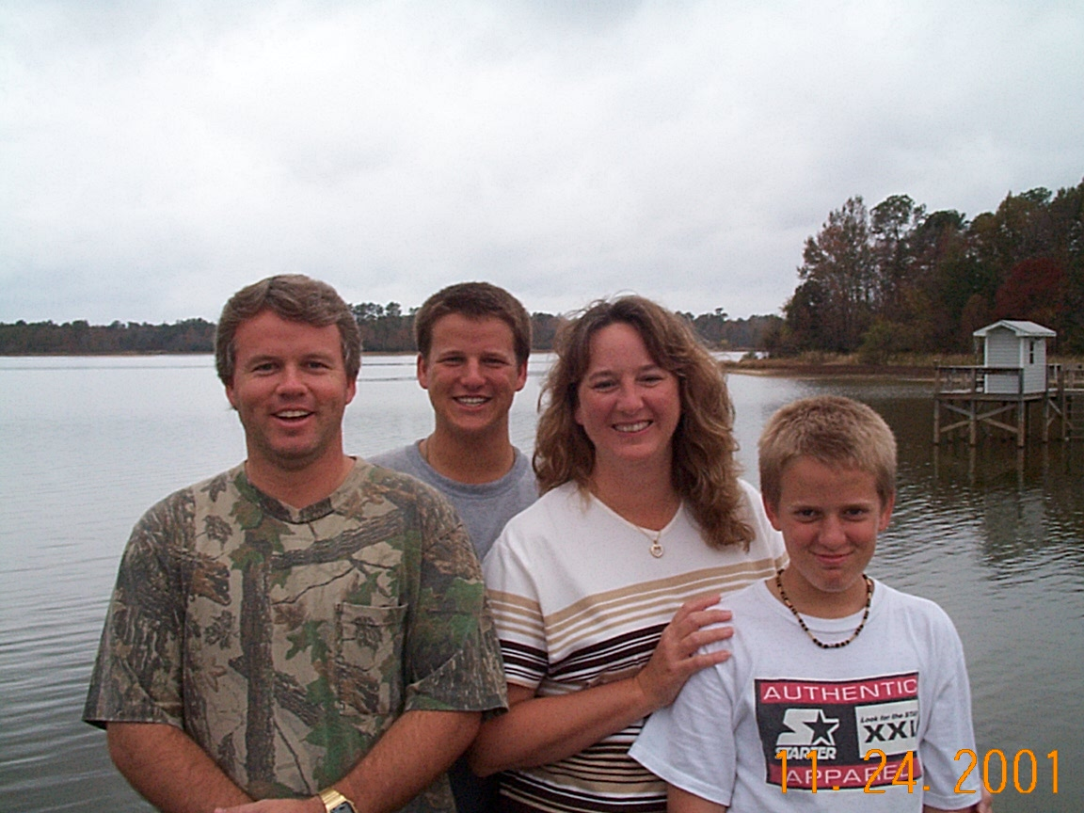 |  | Jim and Nora live on James Island in Charleston, SC. Jim works at Medical University of SC. They have three boys Ryan, Allen, Tray. They all hunt and fish at Grandma lake house and knee board behind grandpa’s boat on Santee lake.
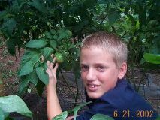 |  | 
James Ryan Moore  Age 14  DOB 10/13/1989 |  | Allen William Moore  Age 18  DOB 1/1/1986
Third Child here  Age 00  DOB 0/0/0 |  | Fourth Child here  Age 00  DOB 0/0/0

