Updating the Radia client from version 3 to version 4
This is NOT an optional upgrade. Student MUST do this upgrade.

The Radia upgrade is the first of several upgrades that will be sent to students this year (2007). It is important that students do each upgrade. Students should familiarize themselves with using Radia to upgrade software. The process of updating software is normally quick and will have directions that will be short steps (step1, step2, step3) process. Radia updates will only run while on the MUSC network.

Guidelines for student updates
Load only software that CHPIT ask you to load.
Most of the software updates run silent
Each update has an “Upgrade Time”. This is the time it takes to load this update under normal conditions. If 30+ students try to load the same update all at once this will extend the time to perform the upgrade.
If an update does not work reboot and try again
Ask for help from a classmate.
Place a call in the help system

Radia Client upgrade to 4.0
Upgrade Time: 4 minutes

STEP 1
Wait until you are at school on the MUSC network and reboot the computer. Login, make sure the wireless connection is up and running. Click on the large black “R” on the task bar to open the Radia client or go to the start menu\programs\Radia Client\Radia Software Manger. Login with “chpstudent” and no password. You should see the window below.
If you do not have the Radia client on your computer go to this link and log a help call. www.musc.edu/chp/kskdjsdkj
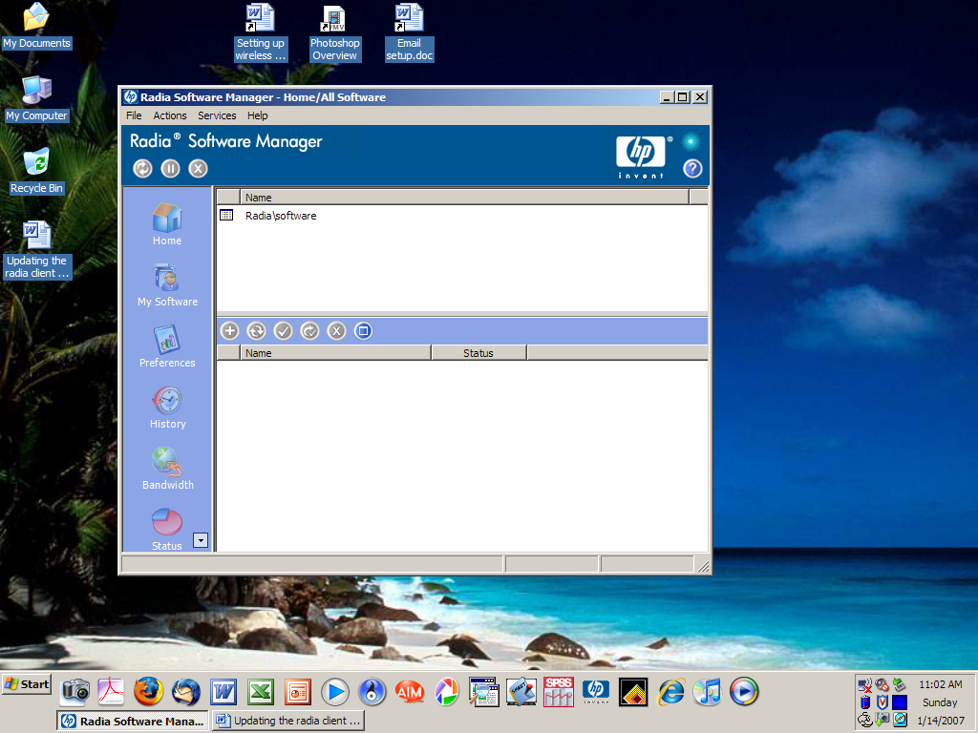 old radia window
Step 2
Select the software update call “CHPStudent Radia 40”
Click the green “+” above this list to install this package
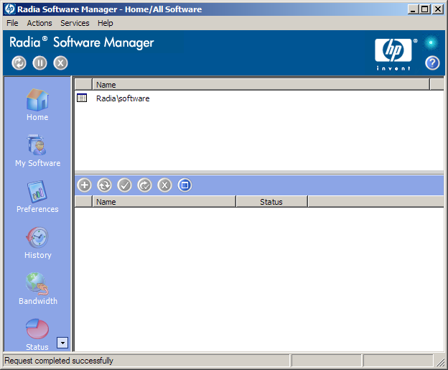
You will see Radia load the installer package. Most of the installers in Radia are “Silent” installers; this means you may not see the installer do anything. After the time allowed for this installation (4 minutes for this upgrade) you should see a check mark beside the program you are installing. The word “Installed” will also appear below the program you are installing like the window below.

Step 3
Fixing your Radia icons on the launch bar at the bottom of your screen.

Step 4
Reboot laptop

