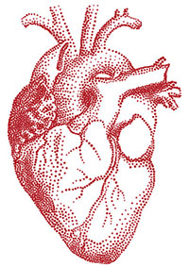

**Make a Heart Pump Science Project**

Find out how the amazing muscles that make up your heart work to keep your blood pumping every day. Make a pump using a jar, a balloon, and two straws to get an idea of how your heart pumps blood.

**What You Need:**

* [**beaker**](http://www.hometrainingtools.com/beaker-glass-250-ml/p/CE-BEI0250/) or wide mouth jar
* large [**balloon**](http://www.hometrainingtools.com/balloon-set-9-piece/p/GS-BALLOON/)**
* 2 [**flexible drinking straws**](http://www.hometrainingtools.com/straw-set-15-pieces/p/GS-STRAWST/)
* wooden skewer
* scissors
* water
* tape
* large pan or sink

**Children under 8 can choke or suffocate on uninflated or broken balloons. Use adult supervision and keep uninflated balloons from children. Discard broken balloons at once.

**What You Do:**

1. Fill the jar half full of water.
2. Cut the neck of the balloon off at the part where it starts to widen into a balloon. Set the neck part aside.
3. Stretch the balloon over the opening of the jar, pulling it down as tightly as you can. The flatter you can get the surface of the balloon, the better.
4. Carefully use the tip of a skewer to poke two holes in the surface of the balloon. Make them about an inch apart from each other and near opposite edges of the jar.
5. Stick the long part of a straw into each hole. The straws should fit securely in the holes so no air can get through around the straws.
6. Slide the uncut end of the balloon neck onto one of the straws and tape it around the straw.
7. Set your pump in a large pan or the sink to catch the pumped water. Bend the straws downward. Gently press in the center of the stretched balloon and watch what happens to the water in the jar.

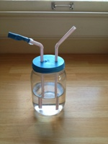

**What Happened:**

You made a simple pump that moved water from the jar through the straws and into the pan. The cut end of the balloon worked as a valve to stop the water from going back down the straw. Your heart pumps blood out into your body through your arteries in a similar way.

Human hearts have four separate chambers inside. This pump shows how one chamber and its valve works. A valve is used to keep blood that has been pumped from one chamber to another from flowing back into the chamber it came from. Try taking the balloon valve off of the straw and pump water again. Did you notice anything different? You likely saw that water still came out of the straw, but without the valve, there was nothing to keep some water from going back down the straw. In order to keep blood moving through your heart and into your body, your heart needs valves to separate its chambers.