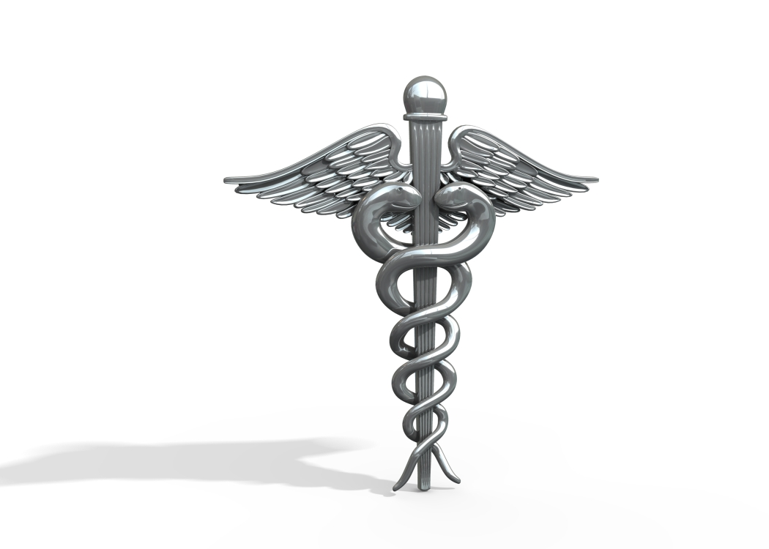Medical Terminology Lesson 2 Post-Test

Name:______________________________________________ Date:_____________

Underline the correct answer.

1. –Algia | Abdomen  Rub, Friction  Pain, Painful condition
2. Crani- | Skull  Brain  Tooth
3.End- | Spinal column  Inside, Within  Cell
4. Hemi- | Half  Entire  Socket
5. Oid- | Double  Empty  Like, Resembling
6.Hyper- | Above, More than normal  On top of  Bound
7. Cyst- | Sac containing fluid  Hernia  Angle at the end of the eyelid
8. Chole- | Green  Ankle  Bile
9. Hypo- | Water  In addition to  Under, Beneath, Deficient
10. –Scop | Look, Observe  Liver  Feel, Touch
11.Hyster- | Uterus, Womb  Breast  Expansion
12.-Ostomy | To create an opening  To enlarge an existing opening  To cut out
Medical Terminology | Lesson 2 Post-Test
13. Para- | Twins  Beside, Beyond  Lung
14.Lysis- | Surgical procedure  Loosening, Destruction, Set free  Abdominal
15.Cervic- | Neck  Uterus  Plate
16. Chondr- | Cartilage  Heart  Socket
17. Cyan- | Blue  Stop, Cease  Cold
18. Hem(at)- | Iron  Covering  Blood
19.Ost- | Cell  Bone  Eye
20. Pyscho- | Mind  Body  Place
21.Lip- | Lip  Fat  Light
22.My- | Cell  Muscle  Maternal
23.Lith- | Foamy  Remove  Stone
24.Opthalm-  Opt- | Eye  Ear  Thumb
25.Proct- | Anus  Bowel  Pain

