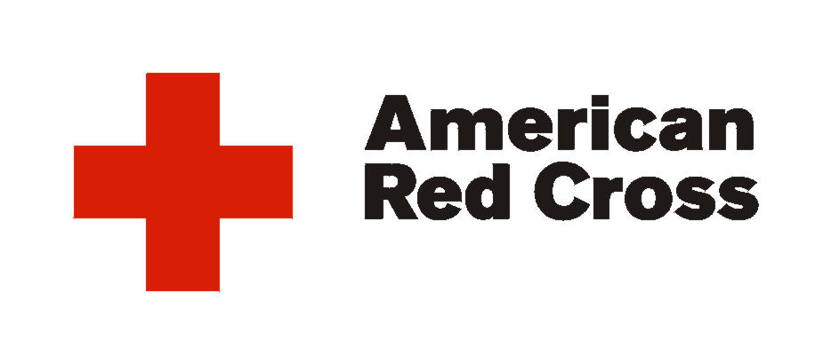

American Red Cross-Carolina Lowcountry Chapter
8085 Rivers Ave. Suite F
N. Charleston, SC 29406
843-764-2323

To Whom it May Concern:

As Director of Volunteer and Youth Services for the American Red Cross- Carolina Lowcountry Chapter
I am willing to support community service and or shadowing by the students from the Health Careers Academy.

Thank You,

Lisa

Lisa Miller-Wills
843-764-2323 Ext. 364

