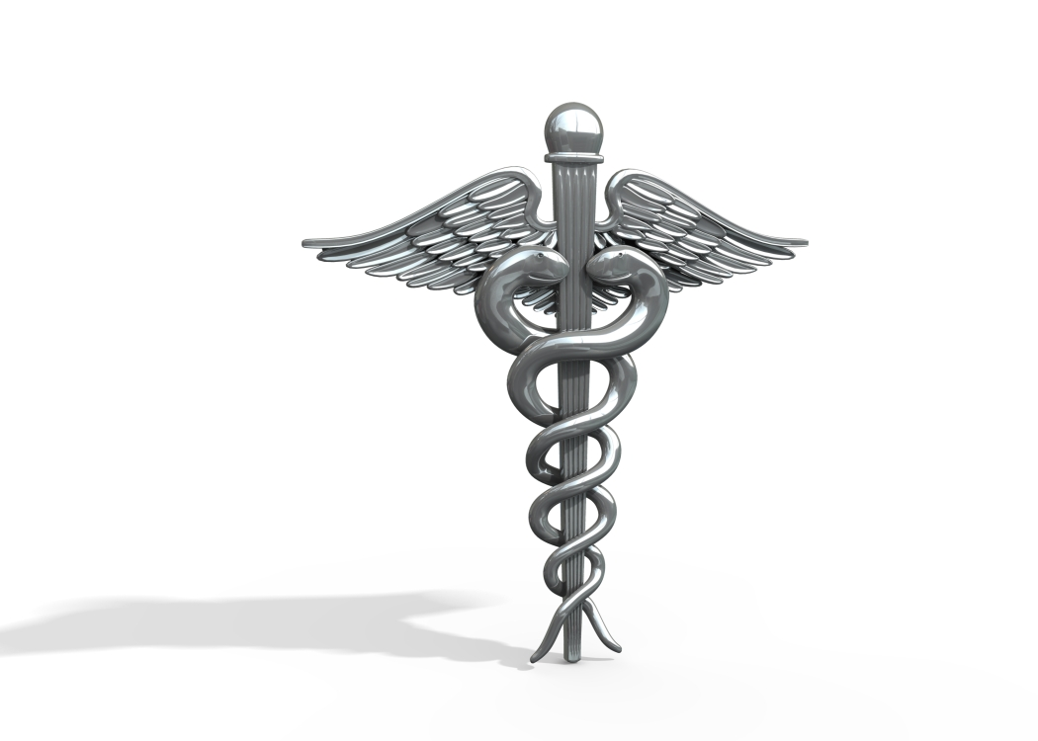 Year 4 Module 2

Basic Anatomy and Physiology Pre-Test

Define
- Anatomy

- Physiology

- Pathophysiology

- Name the five parts which make up the body

- List two types of tissue and give their function

- Name a minimum of five body systems
1.

2.

3

4.

5.

- A __________________ is formed by two or more tissues which are joined to perform a specific function.

