Slide #9: The characteristics of where you are going

|  |  |
| --- | --- |
| Need high school education only | Need advanced education |
| Work regular day hours | Work night and weekends at times |
| Work indoors | Work outdoors |
| Be my own boss | Work for someone else |
| Be in a traditional male/female job | Be in a non-traditional job |
| Do routine tasks each day | Do a variety of tasks |
| Be closely supervised | Work independently |
| Work with machines | Work with people |
| Work with others | Work alone |
| Have a fast-paced job (pressure) | Have a slow-paced job (low key) |
| Earn an average salary | Earn an above-average salary |
| Travel a lot (away from home) | Travel little or not at all |
| Have high-level responsibility job | Have low-level responsibility job |

**Career Development Process**

Who am I?

(Assessment)

* Life priorities
* Interests
* Preferences
* Aptitudes
* Skills
* Achievement

Where am I going?

(Research/Goals)

* Career Information
* Labor market Information
* Career research
* Short and long range goals

How do I get there?

(Acton Plan)

* Skills to develop
* Education/training
* Self-marketing activities: networking, resume’ writing, interviewing, following up
* Obstacles/strategies



**Career Development Process**

Who am I?

(Assessment)

Where am I going?

(Research/Goals)

How do I get there?

(Acton Plan)



**CAREER DEVELOPMENT PROCESS**

What job will I have?

What steps do I take to get there? (education, training, etc.)

What careers interest me?

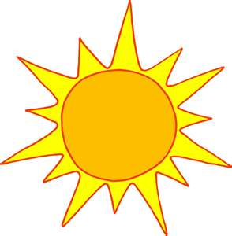

**Steps**

**to a**

**Brighter**

**Tomorrow!**

What classes do I like?

What do I like to do?

(hobbies, interests, etc.)