**Installing Programs for Latex**

*Installing Miktex:*

1. Go to <http://miktex.org/download> and click on the basic Miktex installer

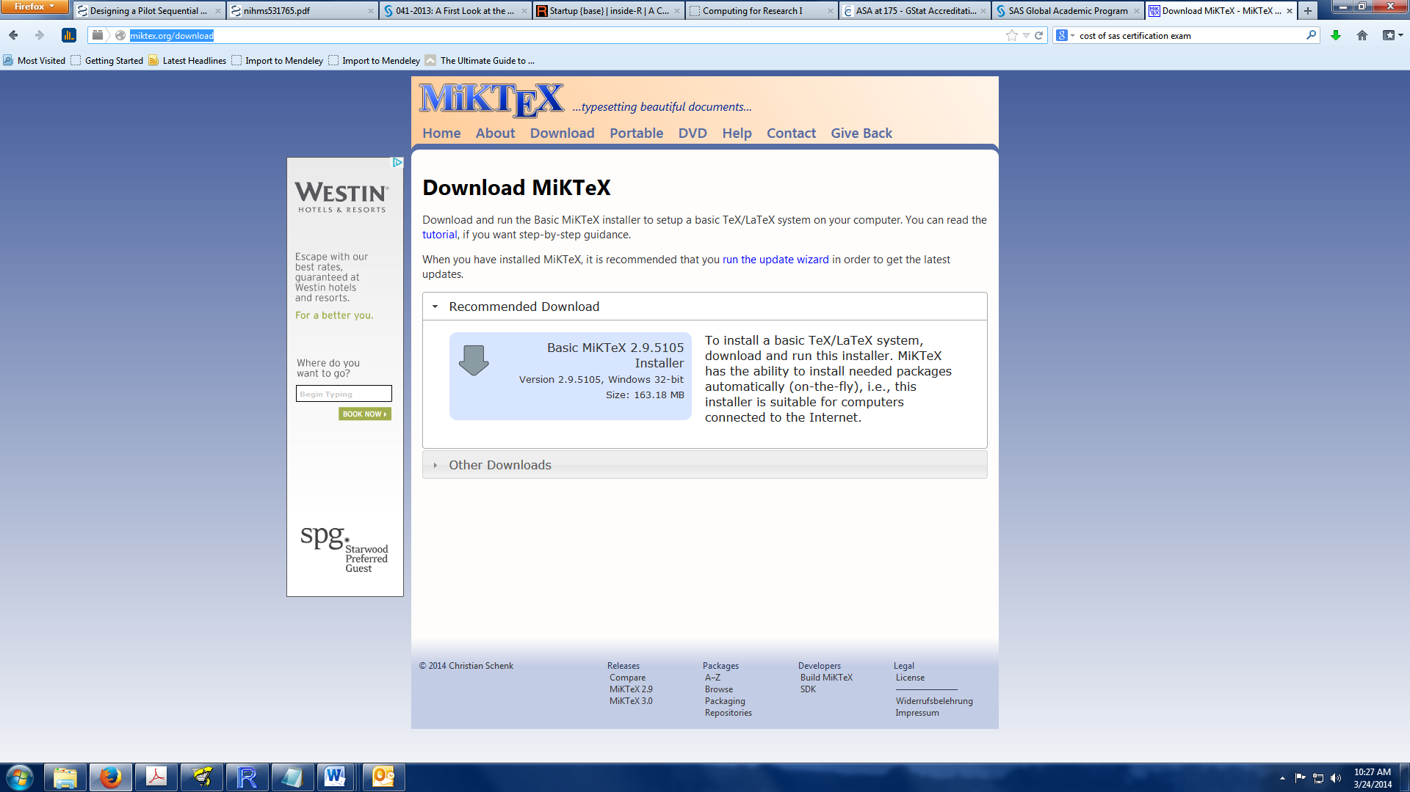

2. Once the installer is downloaded, run the installer. Click through the setup options until you get to the “Completing the Miktex wizard” box. If you need more detailed instructions see <http://miktex.org/howto/install-miktex>

*Installing WinEdt* (Note this is just a front end for Tex/Latex and it is possible to use a different editor such as EMacs if you prefer, but WinEdt is really the easiest if you’ve never seen this before)

1. Go to Start-> Computer->Common ->WinEdt6, and double click on the winedt60 application. Click run and work through the prompts.

2. Once installed, open WinEdt6 and register. Under the help tab click “Register WinEdt…”

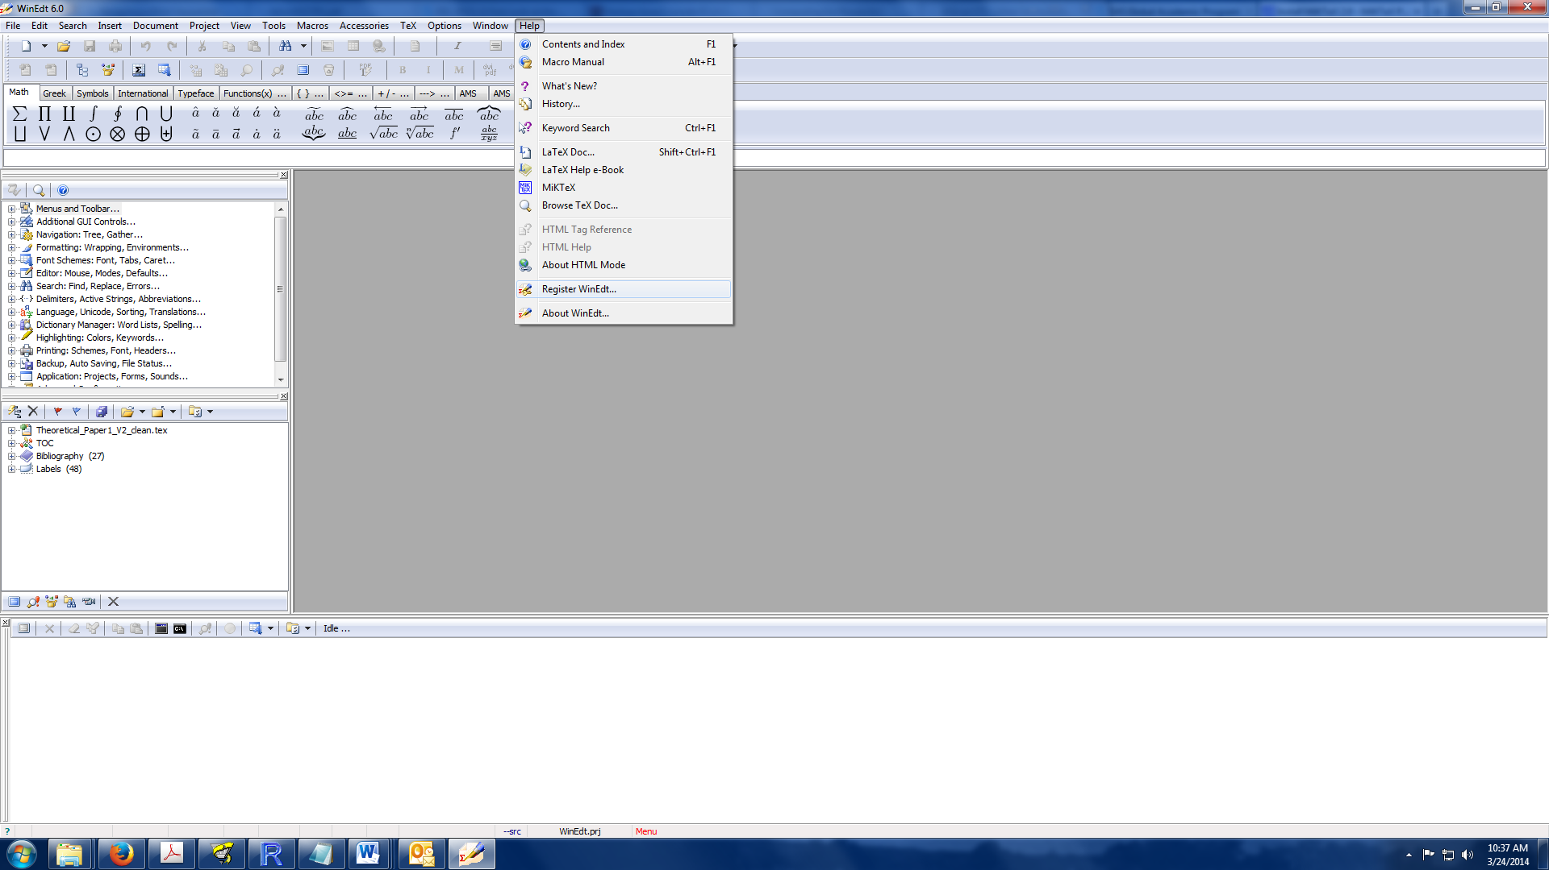

3. Enter the site name as “MUSC (25-user Site License) “ Copy and paste the content inside the quotation marks exactly

4. Enter the site code as “7171345010450491994”