FINAL EXAM
STATISTICS FOR PSYCHOSOCIAL RESEARCH II: STRUCTURAL MODELS
FALL 2004

NAME: __________________________________________________________

I understand the Johns Hopkins University honor and academic codes and I verify that I completed this exam solely on my own without assistance from any other person.

SIGNATURE: ___________________________________________________________

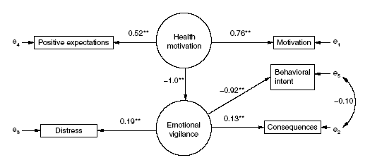

Questions 1-9 ask about the above model, which comes from:

Li, Y & Doukas, DJ Health motivation and emotional vigilance in genetic testing for prostate cancer risk. Clinical Genetics 66 (6), 512-516. December 2004.

All coefficients in the model shown above are standardized.

- (5 points) Write the equation(s) for the measurement model of the latent variable “Health motivation”

- (5 points) Is the latent variable “Health motivation” identified, according to the rules of identification that were presented in class? How did you arrive at your answer?

- (5 points) Write the equation(s) for the measurement model of the latent variable “Emotional vigilance”

- (5 points) Is the latent variable “Emotional vigilance” identified, according to the rules of identification presented in class? How did you arrive at your answer?

- (5 points) Write the equation(s) for the structural component of the model.

- (5 points) Is this structural component of the model identified, according to the rules of identification presented in class? How did you arrive at your answer?

- (6 points) Is the model as a whole identified, using the rules of identification arrived at in class? How did you arrive at your answer?

- (8 points) Comment on the magnitude of the factor loadings for the latent variable “Emotional vigilance.” Based on the loadings, would you say that this latent variable is well measured?
9) (8 points) Interpret the coefficient on the path from “Health motivation” to “Emotional vigilance.”

For questions 10-12 Below are two tables showing the results of a latent class regression model. The latent variable of interest is “mobility/exercise tolerance.” Bandeen-Roche, et al. (JASA,1997) used data from the Women’s Health and Aging Study. Their dataset has 1777 individuals and they chose 5 “tasks” to define mobility. Women were asked whether or not they had difficulty with these tasks. These tasks are doing heavy housework (Hhw), walking ¼ mile (walk), climbing 10 steps (steps), getting in and out of bed or chairs (chair), and lifting 10 lbs. (lift). These items are coded as difficult (1) or not difficult (0) based on self-reported answers.

Table 1: Results of the “measurement model” in the latent class regression model (LCR)

Tasks Class 1 Class 2 Class 3
Hhw 0.05 0.66 0.95
Walk 0.06 0.57 0.94
Step 0.02 0.24 0.88
Lift 0.02 0.37 0.82
Chair 0.01 0.13 0.57

Class size 0.52 0.29 0.19

Table 2: Results of regression of covariates on mobility. Age is measured in years. Arthritis is binary, with 1 indicating self-reported arthritis and 0 indicating no arthritis.

Covariate Coefficient Standard Error of Coefficient
Class 1 vs. Class 3 Age -0.10 0.01
Arthritis -1.92 0.14
Class 2 vs. Class 3 Age -0.79 0.17
Arthritis -0.04 0.01

10. (10 points) Consider the results of the standard latent class analysis in Table 1 (i.e. the parameter estimates for the measurement model as estimated by “LCA”). Describe in a few sentences the interpretation of the classes.

11. The relationship between the latent variable and covariates are shown in Table 2. A. (5 points) Explain what the coefficient -1.92 in the Class 1 vs. Class 3 comparison for Arthritis means. B. (5 points) Describe in words the association between age and mobility.

12. A researcher in gerontology criticizes the latent class modeling, saying that a latent trait model would be more appropriate. A. (9 points) How would mobility be interpreted in a latent trait model versus a latent class model? B. (9 points) Choose one of the two modeling approaches (i.e. latent trait or latent class) and give a justification why you think it is more appropriate way to measure mobility.

