Matrix Operations: Understanding Principal Components Analysis
Jeannie-Marie Sheppard, 2002; revised 2006.

This is a primer to understand some of the math underlying factor analysis.

If you want to try any of these matrix operations yourself, I suggest using R, which is open source code S+. The advantages of R are a) its very powerful b) its free.
To download it, go to http://lib.stat.cmu.edu/R/CRAN/

Put simply, a matrix is a group of numbers arranged within a structure. Examples of matrices that you use all the time are datasets. They are represented by upper case and/or bold letters, i.e, A. For example:

$A=\left[\begin{matrix}1 & 2 & 3 \\ 4 & 5 & 6 \\ 7 & 8 & 9\end{matrix}\right]$

elements (numbers in the matrix) are indexed by their position down, then across. So, A₁₂ = 2. A₂₃ = 6.

Vectors are either rows or columns of a matrix. They are represented by letters that are either underlined, or have a squiggly under them. So, an example of a row vector of matrix A is
A =[1 2 3]. An example of a column vector would be B = [1 4 7].

A scalar is a regular number; each element of a matrix or vector is a scalar.

Matrices are used to solve systems of equations. The easiest cases are ones where you have n equations and n unknowns. As an example:

$\begin{aligned}2x+3y=5 \\ 4x+2y=6\end{aligned}$
A quick inspection yields that the values for x and y which make both of these equation true is x=1, y=1.

If this weren’t the case, you could could restate the problem in matrix form AZ = B
$\left[\begin{matrix}2 & 3 \\ 4 & 2\end{matrix}\right]∗\left[\begin{matrix}x \\ y\end{matrix}\right]=\left[\begin{matrix}5 \\ 6\end{matrix}\right]$
A is comprised of the coefficients of the unknowns. The vector Z is the vector of unknowns (x,y) and B is the vector of answers of the equations.

Now, some notes about operations that can be performed with matrices and vectors. Just because you can do something in regular algebra (i.e., with scalars) doesn’t mean you can do it in linear algebra (algebra with matrices).

Matrix Addition

You can only add two things that are the same shape (i.e., the same number of rows and columns)

Things you can add:

matrix + matrix
$\left[\begin{matrix}1 & 2 \\ 3 & 4\end{matrix}\right]+\left[\begin{matrix}2 & 2 \\ 4 & 4\end{matrix}\right]=\left[\begin{matrix}3 & 4 \\ 7 & 8\end{matrix}\right]$
Notice the sum is also the same shape as the the first two matrices.

$\left[\begin{matrix}2 \\ 1\end{matrix}\right]+\left[\begin{matrix}1 \\ 2\end{matrix}\right]=\left[\begin{matrix}3 \\ 3\end{matrix}\right]$vector + vector
Addition is performed by adding analagous elements in each matrix. Imagine adding matrices A and B.

$\left[\begin{matrix}1 & 2 \\ 3 & 4\end{matrix}\right]+\left[\begin{matrix}2 & 2 \\ 4 & 4\end{matrix}\right]$

Now, we know the answer to this sum (let’s call it C) is also going to be a 2*2 matrix, so we draw it with some spaces:
Now, we want to know C₁₁ is.

The analagous elements of A and B are A₁₁ and B₁₁
$\left[\begin{matrix}1 & 2 \\ 3 & 4\end{matrix}\right]+\left[\begin{matrix}2 & 2 \\ 4 & 4\end{matrix}\right]$

So, C₁₁= A₁₁+ B₁₁ = 1+2 = 3

So we fill it in.

$\left[\begin{matrix}3 & \\ & \end{matrix}\right]$ We would then continue this process with all four elements to get:

$\left[\begin{matrix}3 & 4 \\ 7 & 8\end{matrix}\right]$It should be clear that this process would not work if the two objects being summed were shaped differently- (i.e., how would you add analogous elements, and what shape would the sum take)

Some notes: Matrix addition is commutative (a+b=b+a) and associative (a+(b+c))=((a+b)+c).

Considering the system of equations we began with:
$\begin{aligned}2x+3y=5 \\ 4x+2y=6\end{aligned}$

And its matrix representation:
$$\left[\begin{matrix}2 & 3 \\ 4 & 2\end{matrix}\right]∗\left[\begin{matrix}x \\ y\end{matrix}\right]=\left[\begin{matrix}5 \\ 6\end{matrix}\right]$$

Why can’t you add a scalar to a matrix? It would be the equivalent of adding the number 2 to each of the items in the system of equations. (Remember that we know x=1 and y=1)

$(2(1)+2)+(3(1)+2)≠7$ and $(4(1)+2)+(2(1)+2)≠8$

However, you can multiply a matrix by a scalar. This would be equivalent to multiplying the number 2 by each of the items in the system of equations.

$(2(1)∗2)+(3(1)∗2)=\text{10}$ and $(4(1)∗2)+(2(1)∗2)=\text{12}$

Now a bit more tricky: Multiplying two matrices. A*B=C

In order to multiply two matrices, they don’t have to be the same shape, but do they have to fulfill the following requirement. The number of columns of the first matrix has to equal the number of rows of the second: (I always say to myself “across=down”)

Can do:
a)
$\left[\begin{matrix}1 & 2 \\ 3 & 4\end{matrix}\right]∗\left[\begin{matrix}2 & 2 \\ 4 & 4\end{matrix}\right]$

2 columns = 2 rows

b)
$\left[\begin{matrix}1 & 2\end{matrix}\right]∗\left[\begin{matrix}1 \\ 2\end{matrix}\right]$2 columns = 2 rows
c)
$\left[\begin{matrix}1 & 2 & 3\end{matrix}\right]∗\left[\begin{matrix}1 & 2 & 3 \\ 4 & 5 & 6 \\ 7 & 8 & 9\end{matrix}\right]$ 3 columns = 3 rows

No can do:

d)
$\left[\begin{matrix}1 & 2 \\ 3 & 4\end{matrix}\right]∗\left[\begin{matrix}1 & 2 & 3 \\ 4 & 5 & 6 \\ 7 & 8 & 9\end{matrix}\right]$ 2 columns ≠ 3 rows
e)
$\left[\begin{matrix}1 & 2 & 3 \\ 4 & 5 & 6 \\ 7 & 8 & 9\end{matrix}\right]∗$$\left[\begin{matrix}1 & 2 & 3\end{matrix}\right]$ 3 columns ≠1 row.

Now this last example is interesting, because it is just the reverse of example c, which you can do. This brings us to a key point of matrix math: matrix multiplication is NOT commutative!

So how does one multiply two matrices? Example: A*B=C
$$\left[\begin{matrix}1 & 2 & 3\end{matrix}\right]∗\left[\begin{matrix}1 & 2 & 3 \\ 4 & 5 & 6 \\ 7 & 8 & 9\end{matrix}\right]$$
The product will have the shape m x n where m is the number of rows of A and n is the number of columns of B. So, C will be a 1 x 3 matrix which will look like this:

Consider the element C₁₁

Since it is the 1,1 element, it will be the sum of the products of analogous elements in the first row of A and the first column of B.

$\left[\begin{matrix}1 & 2 & 3\end{matrix}\right]∗\left[\begin{matrix}1 & & \\ 4 & & \\ 7 & & \end{matrix}\right]$First row of A, first column of B

Now, multiply analogous elements: First flip A to be vertical

$\left[\begin{matrix}1 & 2 & 3\end{matrix}\right]$

Now multiply analogous elements of the two columns:

$$\left[\begin{matrix}1 \\ 2 \\ 3\end{matrix}\right]\begin{matrix} \\ \\ \end{matrix}\left[\begin{matrix}1 \\ 4 \\ 7\end{matrix}\right]=\begin{matrix}1 \\ 8 \\ \text{21}\end{matrix}$$
sum = 30

So C₁₁ = 30

$$\left[\begin{matrix}\text{30} & & \end{matrix}\right]$$

Now for C₁₂.

Repeat process with row one of A and column 2 of B

$\left[\begin{matrix}1 \\ 2 \\ 3\end{matrix}\right]\begin{matrix} \\ \\ \end{matrix}\left[\begin{matrix}2 \\ 5 \\ 8\end{matrix}\right]=\begin{matrix}2 \\ \text{10} \\ \text{24}\end{matrix}$
sum = 36

So, C₁₂ = 36

And then C now looks like this:

$$\left[\begin{matrix}\text{30} & \text{36} & \end{matrix}\right]$$

Repeat process with row one of A and column 3 of B to get C₁₃.

In general once you know the frame for C (how many rows, how many columns) then element Cij will be the sum of the products of row I of A and column j of B. for example:

$\left[\begin{matrix}1 & 2 & 3 & 4 \\ 5 & 6 & 6 & 8 \\ 7 & 8 & 8 & 8 \\ 6 & 0 & 2 & 3\end{matrix}\right]$*$\left[\begin{matrix}1 & 2 & 3 & 4 \\ 5 & 6 & 6 & 8 \\ 7 & 8 & 8 & 8 \\ 6 & 0 & 2 & 3\end{matrix}\right]$=

Now, if we want to know the element C₃₂, then we take the sum of the products of row 3 of A and column 2 of B.

Flip [7 8 8 8] to make it horizontal, then C₃₂ is: (7*2)+(8*6)+(8*8)+(8*0)=126
Of course, you’d have to do this 16 times, and that would be unpleasant. Lots of computer programs do this and lots more for you, I recommend R.

Back to our matrix representation of our system of equations.
$$\begin{aligned}2x+3y=5 \\ 4x+2y=6\end{aligned}$$

$$\left[\begin{matrix}2 & 3 \\ 4 & 2\end{matrix}\right]∗\left[\begin{matrix}x \\ y\end{matrix}\right]=\left[\begin{matrix}5 \\ 6\end{matrix}\right]$$

If we multiply the two things on the right hand side (a 2 x 2 and a 2 x 1), we get (remember rows of A, columns of B) a 2 x 1 matrix.

If you do this you get:
$$\left[\begin{matrix}2x+3y \\ 4x+2y\end{matrix}\right]=\left[\begin{matrix}5 \\ 6\end{matrix}\right]$$

which is where you started.

Special Matrices

I is the identity matrix – it is the matrix version of the number 1. It consists of a diagonal of 1’s with all other elements equal to 0. It has to be square.
Examples:
$\left[\begin{matrix}1 & 0 \\ 0 & 1\end{matrix}\right]$ or $\left[\begin{matrix}1 & 0 & 0 \\ 0 & 1 & 0 \\ 0 & 0 & 1\end{matrix}\right]$

the product of any matrix A and I will be A.

Transpose

A^{T} means “A transpose”
A =

When you transpose, the rows become columns, and the columns become rows. You could also think of it as rotating the matrix 180 degrees about the diagonal axis.

A^{T}= $\begin{aligned}\left[\begin{matrix}1 & 2 & 3\end{matrix} | \right] \\ \end{aligned}$

Another way you could say this is that A_{ij}=A^{T}_{ji}, which just means that if something is in the 3rd row and 2nd column of A, it will be in the 2nd row and 3rd column of A^{T}.

If A = A^{T}, then the matrix is called symmetric. In order to be symmetric, a matrix would have to be square. An example of a symmetric matrix would be I.

Inverse of a Matrix
The inverse of a scalar, say n, is just $\frac{1}{n}$. Inverses have the property that a number multiplied by its inverse = 1 The same is true in matrix math, A*A⁻¹=I; although calculating the inverse is rather more difficult. For square matrices, if A*A⁻¹=I, then A⁻¹ *A=I.

If A*A⁻¹=I and A⁻¹ *A=I, then the matrix is nonsingular, or, invertible.

There is a way to calculate by hand an inverse (if it exists), but it takes forever; use the solve command in R if you ever want to do this.

Determinant

For a 2 x 2 matrix, the determinant is ad-bc.

$$\left[\begin{matrix}a & b \\ c & d\end{matrix}\right]$$

For a 3 x 3 matrix, the determinant is aei+bfg+dhc-ceg-ibd-ahf. You should be able to see a pattern.

$$\left[\begin{matrix}a & b & c \\ d & e & f \\ g & h & i\end{matrix}\right]$$

Really though, for anything bigger than a 2 x 2 matrix you should use the R command det

Some important properties of determinants:

For any square matrix, det(A^{T}) = det(A)

If A has either a zero row or a zero column, then det(A) = 0

If A has two equal rows or two equal columns, then det(A) = 0

If the determinate is 0, you won’t be able to invert the matrix.

You’ve probably been wondering where this is going – don’t worry, we’re almost there.

Rank

Consider again our system of equations
$\begin{aligned}2x+3y=5 \\ 4x+2y=6\end{aligned}$
One way to solve this system is to graph the two lines:

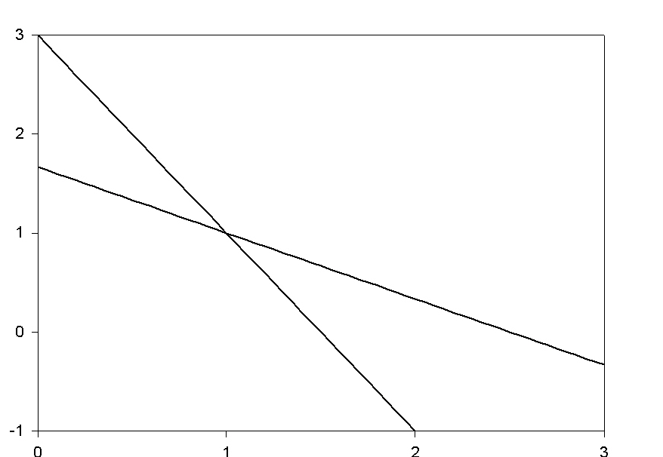
The solution is the intersection (1,1). We already knew this.

Now consider the system
$$\begin{aligned}2x+3y=5 \\ 4x+6y=\text{10}\end{aligned}$$

Because they are really the same line, they intersect at infinitely many places, so there is no unique solution.

The rank of a matrix is the number of rows of that matrix which are linearly independent. If a matrix row is linearly independent, then it is not a multiple of another row, nor is it a linear combination of any of the other rows in the matrix. You can’t arrive at it by doing something to 1 or more of the other rows. The rank of the matrix of our first system of equations is 2. The rank of the matrix of our second system of equations is 1.

Now consider the system

$\begin{aligned}2x+3y=5 \\ 4x+2y=6 \\ x+2y=2\end{aligned}$ this has the matrix representation $\begin{aligned}\left[\begin{matrix}2 & 3\end{matrix} | \right]\left[\begin{matrix}4 & 2\end{matrix} | \right] \\ \end{aligned}$

The rank of the matrix of coefficients is 3.
Verify for yourself that the multiplication on the left-hand side of the equation is do-able.

Now, let’s graph this and see what happens.

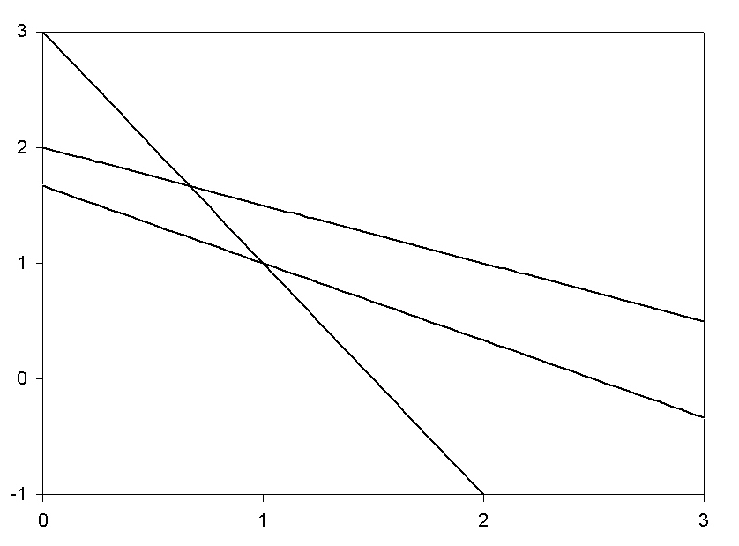

Oops! There are no solutions to this system of equations. This is because the rank of the matrix is larger than the number of unknowns. The issue isn’t necessarily the number of equations, but the rank of the matrix.

Eigenvalues, Eigenvectors

The purpose of eigenvalues (at least in the context of this class) is data reduction. You’ve got these matrices of correlations, and you want to distill it into something simpler.

λ is an eigenvalue of A iff (iff means if and only if)
There is a nonzero vector x such that Ax = λx
The matrix A - λI is singular
Det(A-λI) = 0

Below is example using R for extracting eigenvalues and eigenvectors form a variance/covariance matrix (called matrix)

>list(matrix)

This is the variance-covariance matrix
[[1]]
[,1] [,2] [,3]
[1,] 1.0 0.4 0.6
[2,] 0.4 1.0 0.8
[3,] 0.6 0.8 1.0

The eigen command returns eigenvalues and eigenvectors
> emat<-eigen(matrix)

I assigned the output to emat. So the entity emat has two components:

$values
[1] 2.2149347 0.6226418 0.1624235

$vectors
[,1] [,2] [,3]
[1,] 0.5057852 -0.8240377 0.2552315
[2,] 0.5843738 0.5449251 0.6013018
[3,] 0.6345775 0.1549789 -0.7571611

Now, let’s verify the assertion that Ax = λx
A is the variance covariance matrix
X is the eigenvector
λ is the eigenvalue

So, I multiply the matrix by the first eigenvector with this command:

> Ax<-matrix%*%emat$vectors[,1]

The command a bit complicated but it’s really not. In R, to do an operation on a matrix, you surround the command by %’s, and <- is the assignment operator, it sometimes helps to read it as “gets”.

You could restate this as “Ax gets the value matrix multiplied by the first eigenvector from emat”

> Ax<-matrix%*%emat$vectors[,1]
> list(Ax)
[[1]]
[,1]
[1,] 1.120281
[2,] 1.294350
[3,] 1.405548

so, this vector is A*x

Now, that vector will be the same as λ*x

> lambdax<-emat$values[1]*emat$vectors[,1]
> list(lambdax)
[[1]]
[1] 1.120281 1.294350 1.405548

So, why have we done this? The point is, we’ve boiled down the matrix into three vectors (eigenvectors) and three scalars (the lambdas)

Now, what does this have to do with factor analysis?

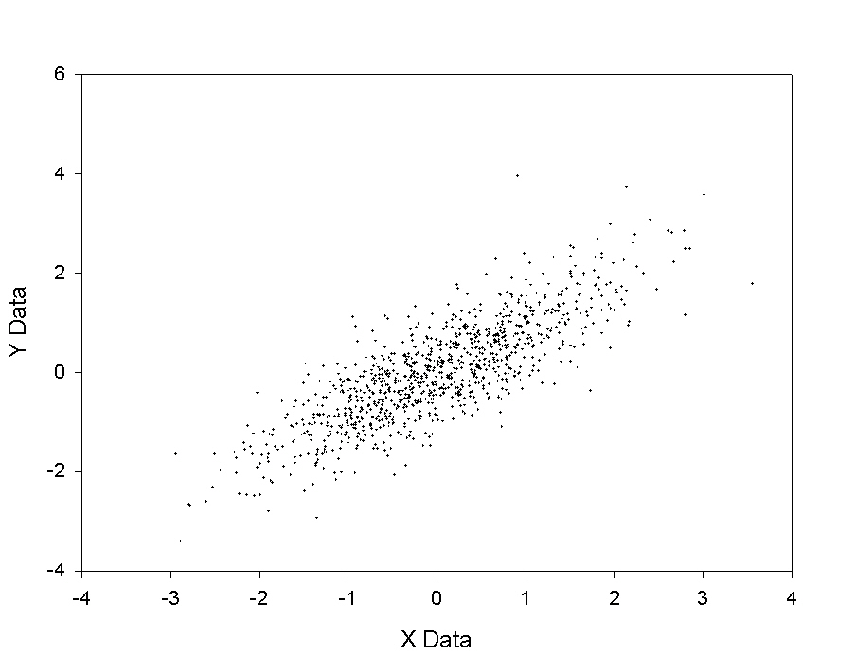
The purpose of factor analysis is to explain correlations between observed (or indicator or manifest) variables by proposing the existence of one or more latent variables.

If each person had a score on 10 different indicators, then each person would have a response vector with ten elements. If you wanted to plot these vectors, you would need to plot it in a 10-dimensional space. That impracticable, and difficult for us to visualize, so we’re going to first look at an example with 2 observed variables.

Here is a plot of randomly generated data that has a ~0.8 correlation.
Now, what if, instead of indexing each person on the basis of their x and y value (in two dimensions), you could index them in only one dimension?

Now, here is the matrix of correlations:

[,1] [,2]
[1,] 1.000000 0.818164
[2,] 0.818164 1.000000

Now let’s get the eigenvalues and eigenvectors

> eigen(cormat)
$values
[1] 1.818164 0.181836

$vectors
[,1] [,2]
[1,] 0.7071068 0.7071068
[2,] 0.7071068 -0.7071068


Now, about the eigenvalues:

Go to http://www.freeboundaries.org/java/la_applets/Eigen/ and play with this java applet.

The eigenvectors describe two new axis, rotated 45º from the original axis (don’t confuse this rotation with “factor rotation”. The JAVA applet shows the unit circle in dark green(a circle with radius=1). The red circle is the image of the circle created by the matrix. The eigenvectors aren’t generally used in factor analysis – though I’m told they are useful in other disciplines, such as crystallograpy.

Let’s draw them onto the graph of the data.

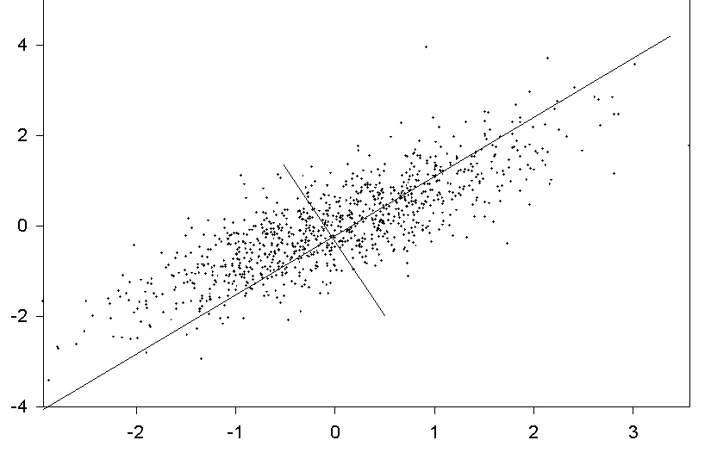
Now, because of the degree to which the data are correlated, knowing just someone’s value along the long axis gives you a lot of information about them. In fact, the proportion of total variance explained by an axis is equal to the corresponding eigenvalue divided by the number of variables.
In this case $\text{proportion}=\frac{1\text{.}\text{82}}{2}=\text{.}\text{91}$

Factor loadings tell you what proportion of variance of a variable is accounted for by a given factor. Why is this different from the proportion just mentioned?

Now, the matrix of factor loadings is equal to the matrix of eigenvectors * $(\sqrt{λ}I)$
$(\sqrt{λ}I)$=$\left[\begin{matrix}\sqrt{1\text{.}\text{82}} & \sqrt{\text{.}\text{18}}\end{matrix}\right]∗\left[\begin{matrix}1 & 0 \\ 0 & 1\end{matrix}\right]=\left[\begin{matrix}1\text{.}\text{35} & 0 \\ 0 & \text{.}\text{42}\end{matrix}\right]$

matrix of factor loadings = $\left[\begin{matrix}\text{.}\text{71} & \text{.}\text{71} \\ \text{.}\text{71} & −\text{.}\text{71}\end{matrix}\right]∗\left[\begin{matrix}1\text{.}\text{35} & 0 \\ 0 & \text{.}\text{42}\end{matrix}\right]=$$\left[\begin{matrix}\text{.}\text{96} & \text{.}\text{30} \\ \text{.}\text{96} & \text{.}\text{30}\end{matrix}\right]$

When you postmultiply a matrix by a diagonal matrix it rescales its columns by the values in the diagonal matrix.

note: on page 19 of Kim and Mueller, the matrix of eigenvalues is wrong; it should just be the squareroots of the eigenvalues, not their inverses

If you sum the squares of the factor loadings across (in a row) they sum to 1
If you sum the squares of the factor loadings down (in a column) they sum to the eigenvalue.

This follows because the squares of the eigenvalues are proportions of variances of variables.

What we’ve just done is principle components analysis. Its important to note that it doesn’t rely on any assumptions about the data (i.e., normality)… It is purely a mathematical operation on a matrix.

