PROBLEM SET#1
HANDOUT

Helpful STATA Commands:

- to open a file in Stata:

. use "A:\filename.dta", clear

Alternatively
File → Open → Filename

- Summarizing variables

. sum var1

- Graphing a histogram
If you are using STATA 7.0
Graph Varname, ylabel xlabel title (title) saving (name.wmf)

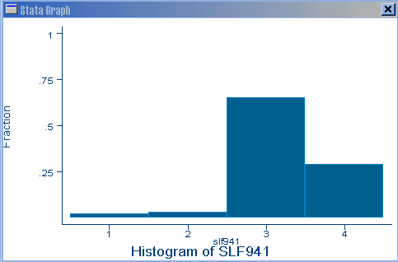

If you are using STATA 8.0
. histogram varname [weight] [if exp] [in range] [, [discrete_options|continuous_options] common_options ]

e.g. histogram slf961, discrete ylabel() xlabel() title(Histogram of slf961) saving(figure1.wmf, replace)

- Generating a variable
a-
. gen age2 = age*age
. gen totinc = inc1+inc2+inc3

b-
gen var1=1 if varX>=10 & varX<100 & varX!=0

replace var1=0 if varX<10 & varX!=0
*!= means “is not equal to”

- Pearson’s correlation

. corr var1 var2 var3 var4

- Using STATA as a scientific calculator

. display (23+15*85+3^2)/4
326.75

- Cronbach alpha

. alpha var1-var10
. alpha var1-var10, item
(option “item” will generate for you also the “corrected” item-total correlations)

- Two way ANOVA
. anova main_variable id item_of_mainvariable

- Tabulation of data
. tab varX
. tab1 var1 var2 var3 var4

- Crosstabulation
. tab varX varY

- Reshaping long vs. wide

. reshape wide varXi, i(id) j(item)
reshape converts data from wide to long form and vice versa. Think of the data as a collection of observations x_ij. One such collection might be

(wide form)

-i- ------- x_ij --------
id sex inc80 inc81 inc82
-------------------------------
1 0 5000 5500 6000
2 1 2000 2200 3300
3 0 3000 2000 1000

(long form)
-i- -j- -x_ij-
id year sex inc
-----------------------
1 80 0 5000
1 81 0 5500
1 82 0 6000
2 80 1 2000
2 81 1 2200
2 82 1 3300
3 80 0 3000
3 81 0 2000
3 82 0 1000

reshape converts data from one form to the other:
. reshape long inc, i(id) j(year) (goes from top-form to bottom)
. reshape wide inc, i(id) j(year) (goes from bottom-form to top)

- Kappa statistics
. Kap var1 var2, tab

